# Homework 3

**Name: Syeda Mishra Saiara**

**uID: u1457424**

## Assignment 1: Targeted and Non-Targeted Adversarial Attacks, and Defenses

### Preparations:

The goal of this homework is to become familiar with the implementation of the adversarial attacks/defenses and backdoor attacks. The first assignment was about learning to construct adversarial attacks on a digit recognition model. There were files given to us, a dataset in a pickle file named ***mnist.pkl,*** and a pre-trained model named, ***trained_network.pkl***  for the task.   
  
For some reason, all the mounted files in GoogleColab from my personal drive were not working as coded for the directories. I had to manually change some things from ***“mnist_loader.py”, “trained_network.pkl”,*** and ***“netwrok.py”*** for the whole task. I changed the ***“mnist.pkl”*** loading directory in **“mnist_loader.py”**, changed the calling of **network.network** module from the “trained.pkl” file.

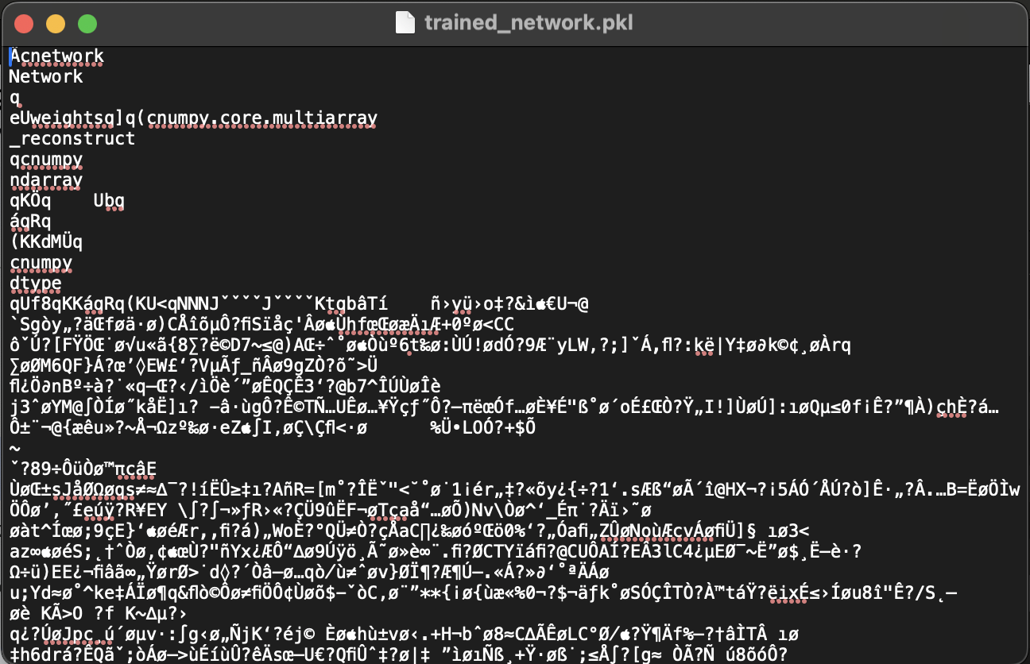

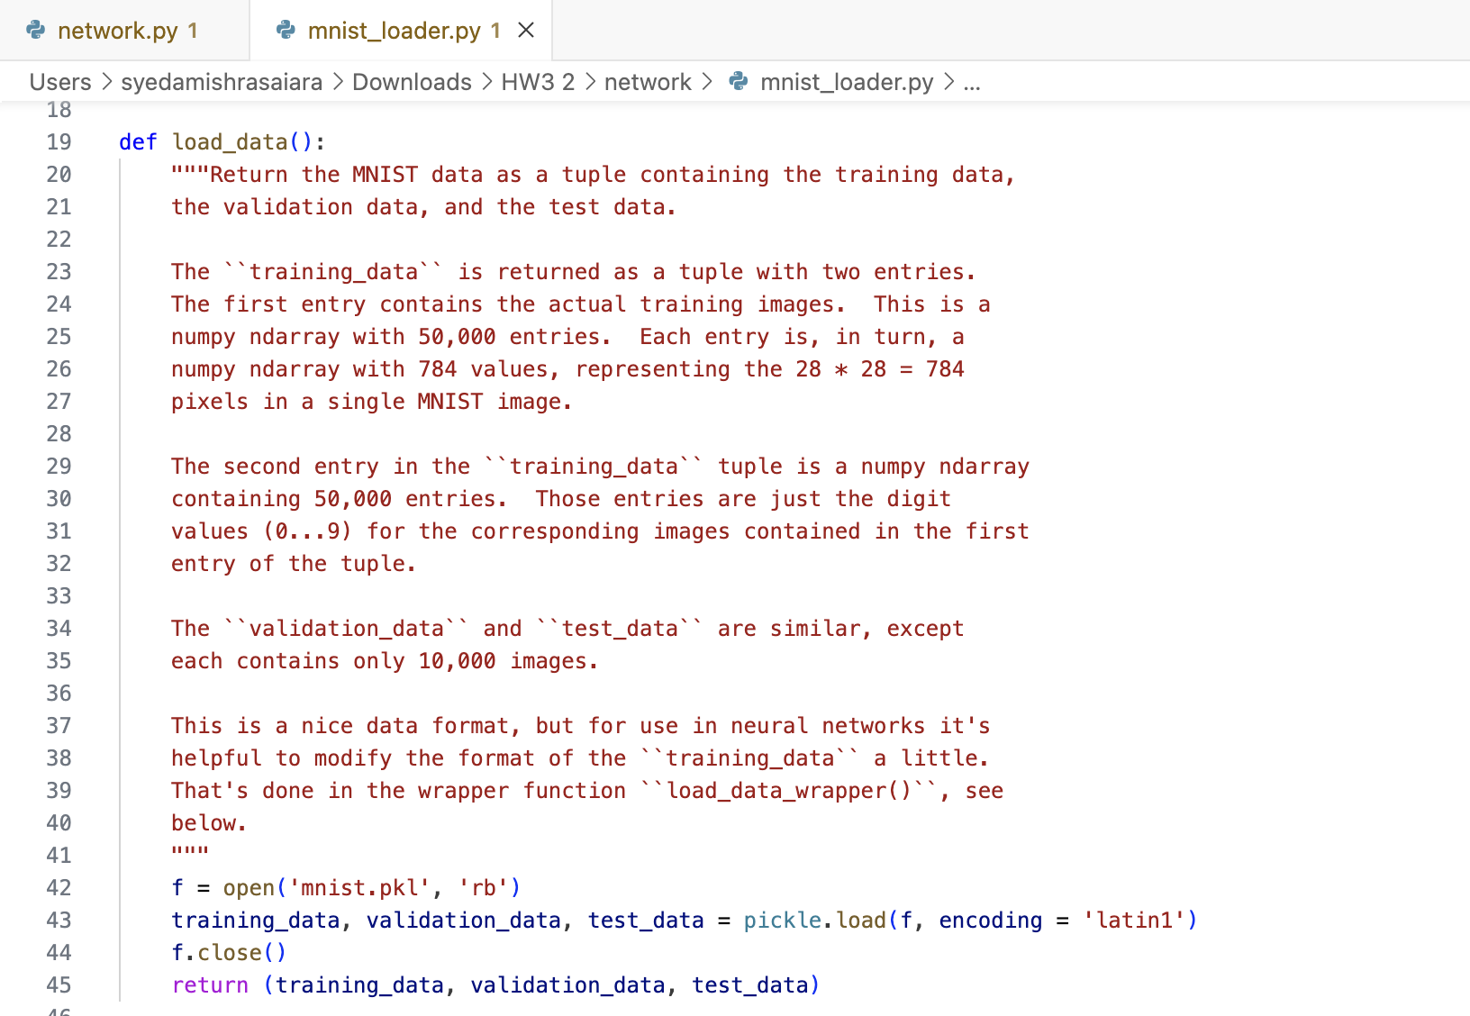

After resolving these directory issues, I loaded the pre trained model, and executed that. I ran the network to see the output of the network prediction without any sorts of attacks or modification. It worked fine.

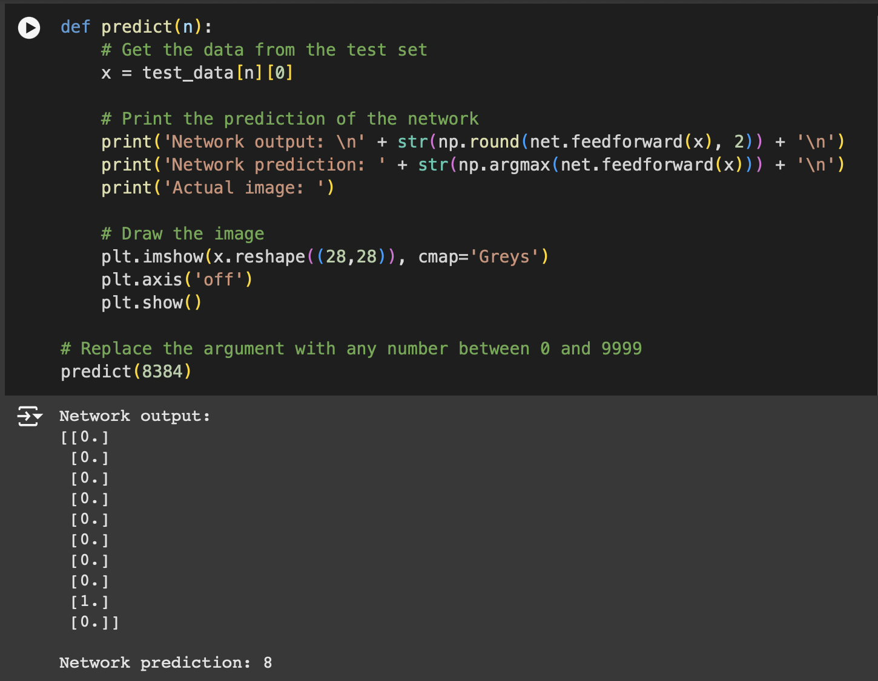

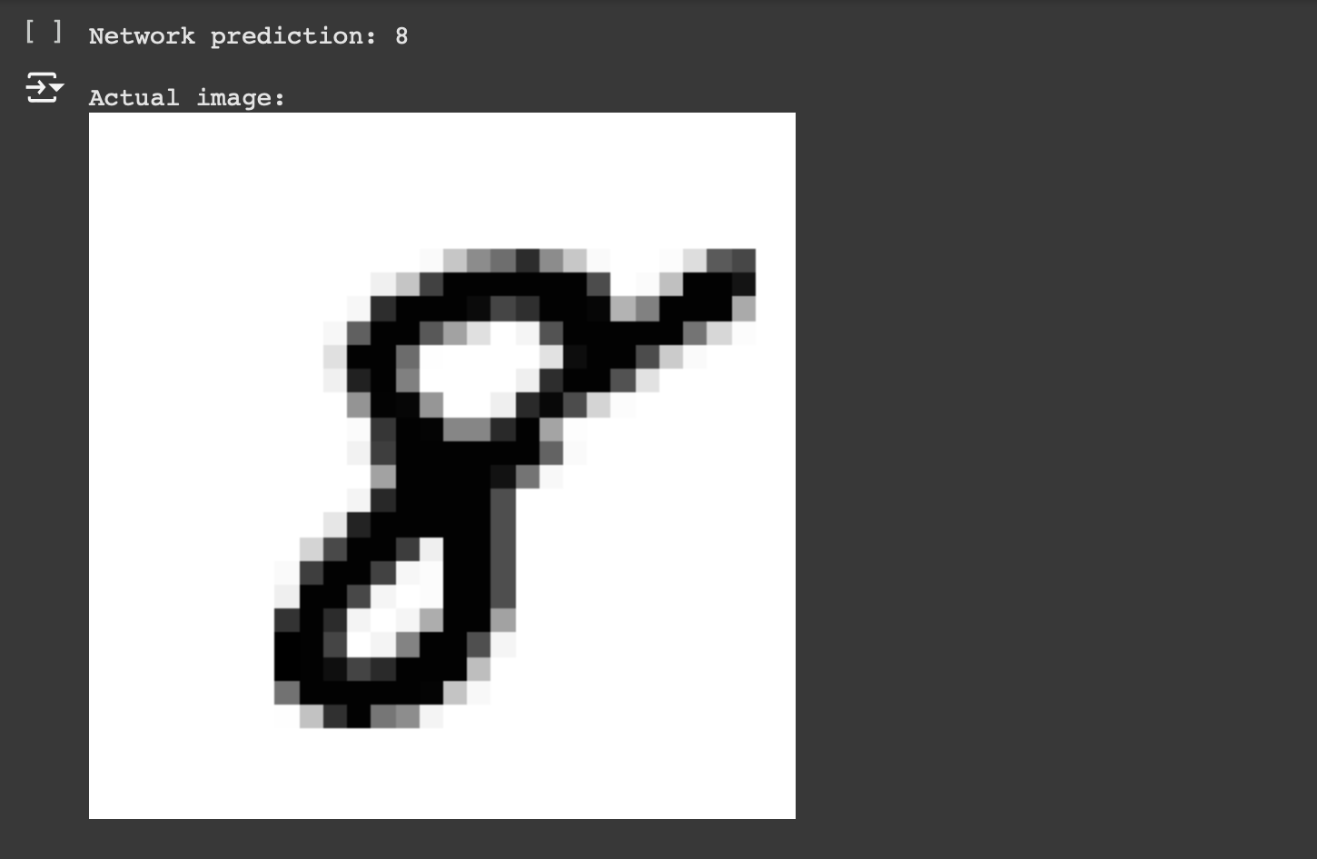

Finally, the sigmoid function, its derivative, and a function to find the gradient derivatives of the cost function, ∇𝑥𝐶 with respect to the input 𝑥⃗ , with a goal label of 𝑦⃗𝑔𝑜𝑎𝑙 (input derivatives) were calculated.

### (a) Non Targeted Attack:

Now, it was finally the turn to do the adversarial attacks. The first function, **nonTargetedAdversarial**, is for generating the nor targeted attack for the given digit recognition model. It takes an input image and iteratively modifies through gradient-based updates to maximize the model's prediction error. But it also maintains the pixel values within the given range.

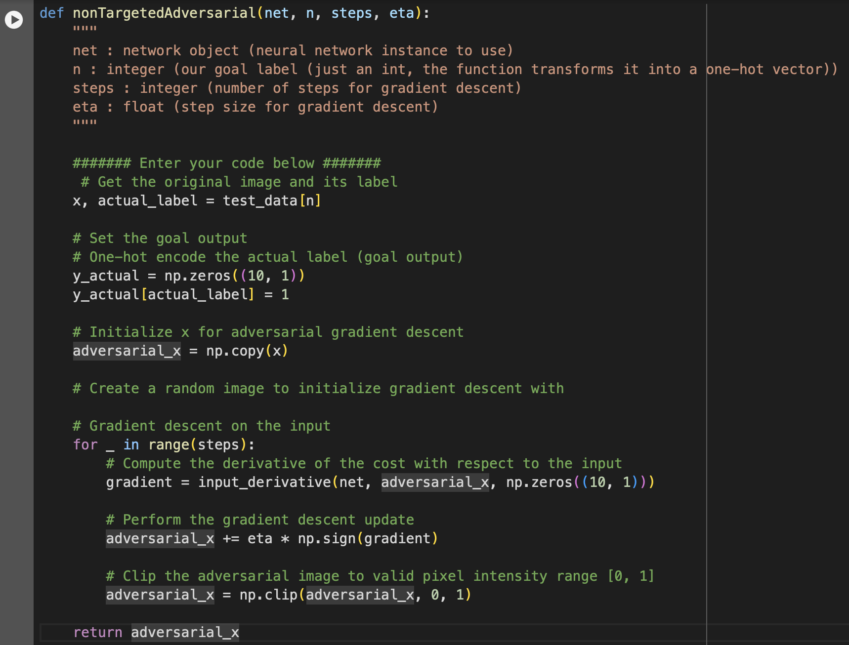

The **generate** function works as a wrapper to create and display the non-targeted adversarial attack. It runs the **nonTargetedAdversarial** function to perturb the input image. It also obtains the model's prediction by performing the forward pass on the adversarial input. Visualizations were added after each wrapper function to have the idea whether the attack was working or not.

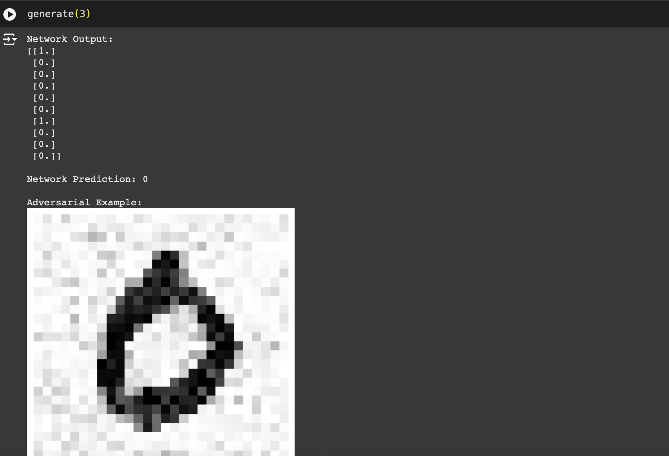

The result shows, after the attack, the network output probability was manipulated to predict as the adversarial.

### (b) Targeted Attack:

Now, it was turn for the targeted attack on the model. I wrote a **targetedAdversarial** function that generates a targeted adversarial attack. It also modifies input images through gradient descent like the non-targeted one. However, it minimizes the difference from a target image while tricking the network into identifying the hostile image as a certain target label. To make sure the adversarial example stays around the target image, a regularization term is added. This feature illustrates how to create focused attacks to evaluate model weaknesses.

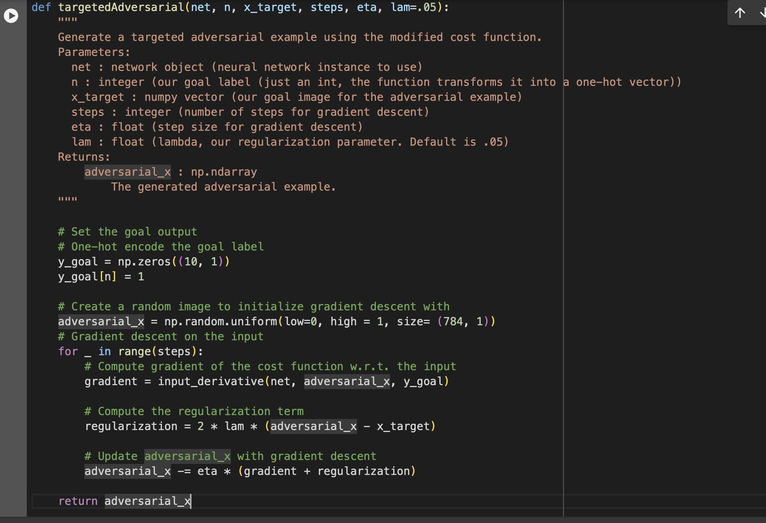

There was a wrapper function, named **generate_advSample** that generates and displays a targeted adversarial example for a neural network model. In order to trick the model into categorizing a random instance of a given target label as the target label, it calls the **targetedAdversarial** function to produce an adversarial image that looks like the target image. Similar to the prior ones I added visualizations to assess the model's vulnerability to targeted attacks.

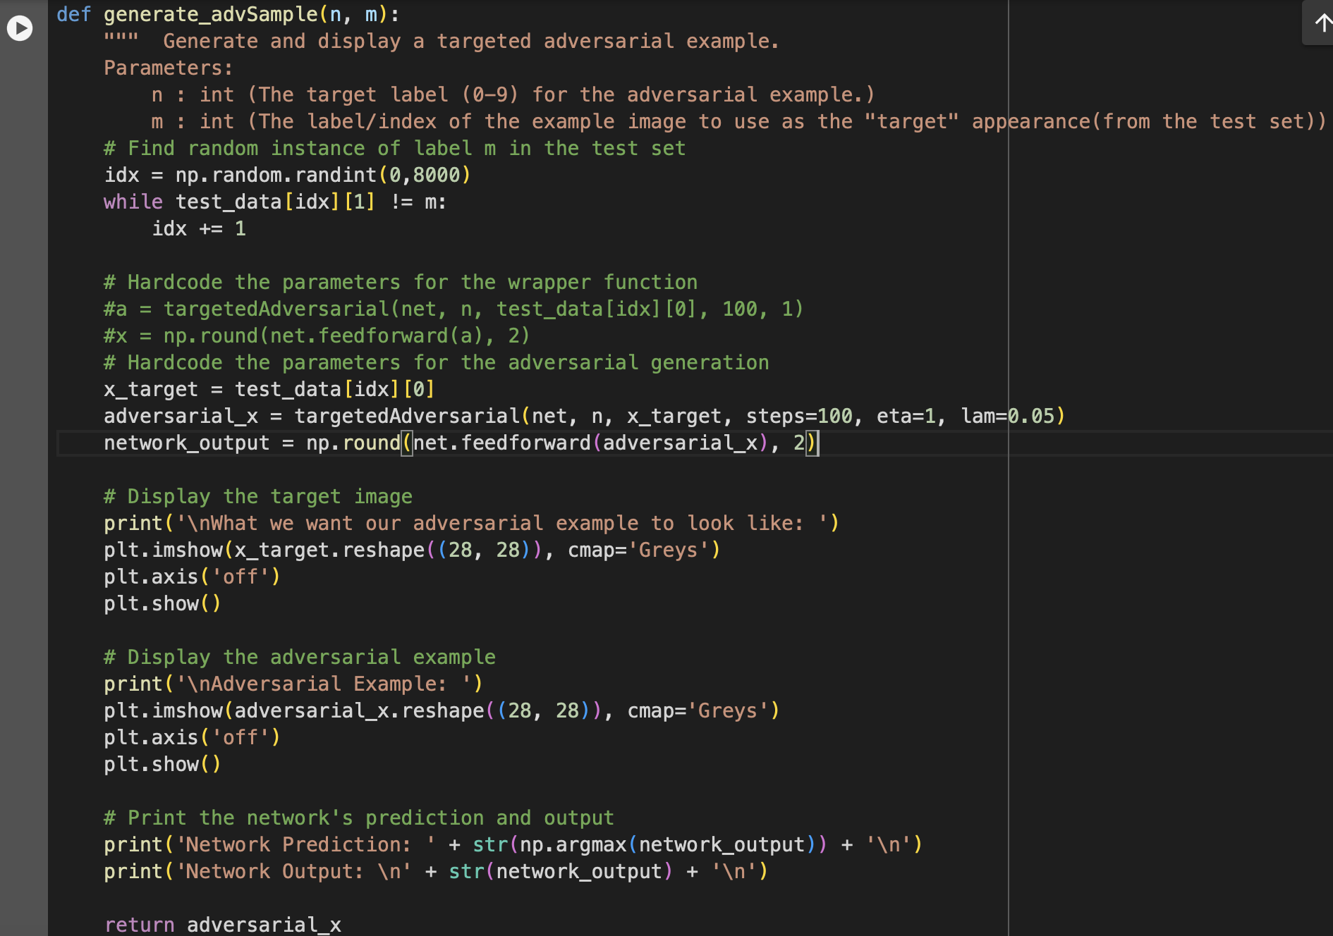

For the result part, the first image below shows the **target image** that the adversarial example is trying to copy. This serves as the goal appearance for the adversarial input, with a target label of 8.

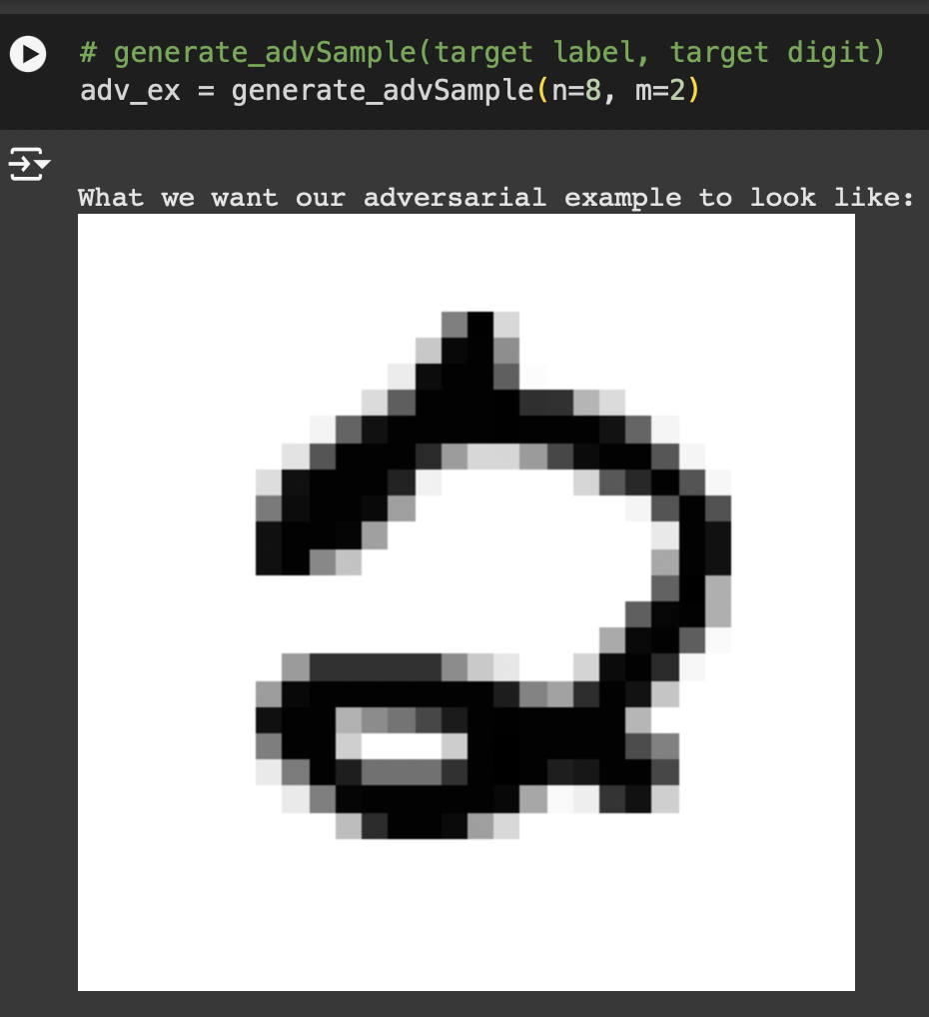

This second image illustrates the **adversarial example** generated by perturbing an input image using the generate_advSample function.The Network Output indicates that the neural network was effectively deceived into predicting the label 8 for this adversarial image, with a high confidence of 0.96, whereas, it was supposed to predict the label 2.

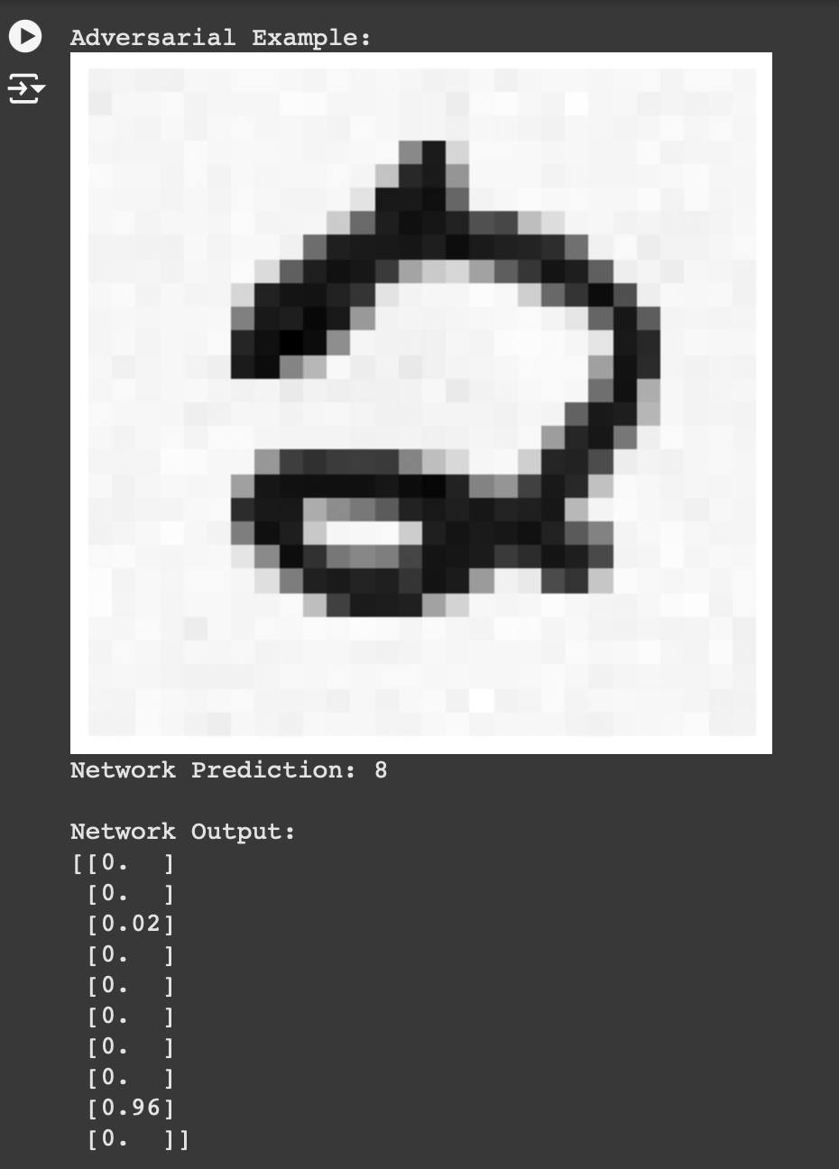

### (c) Simple defense against adversarial attacks:

Now that we successfully did the targeted and non targeted attacks, a simple defence mechanism was the last part for it. The assignment module indicated for the binary thresholding against these attacks. The **simple_defense** function implements that binary thresholding method as a simple defense against adversarial attacks on the provided neural network. Using the **generate_advSample** function, it first creates an adversarial example using the target and original labels supplied. To lessen the effect of adversarial perturbations, the function then uses binary thresholding, changing pixel values to either 0 or 1. Visualizations were added to confirm the accuracy of the defense.

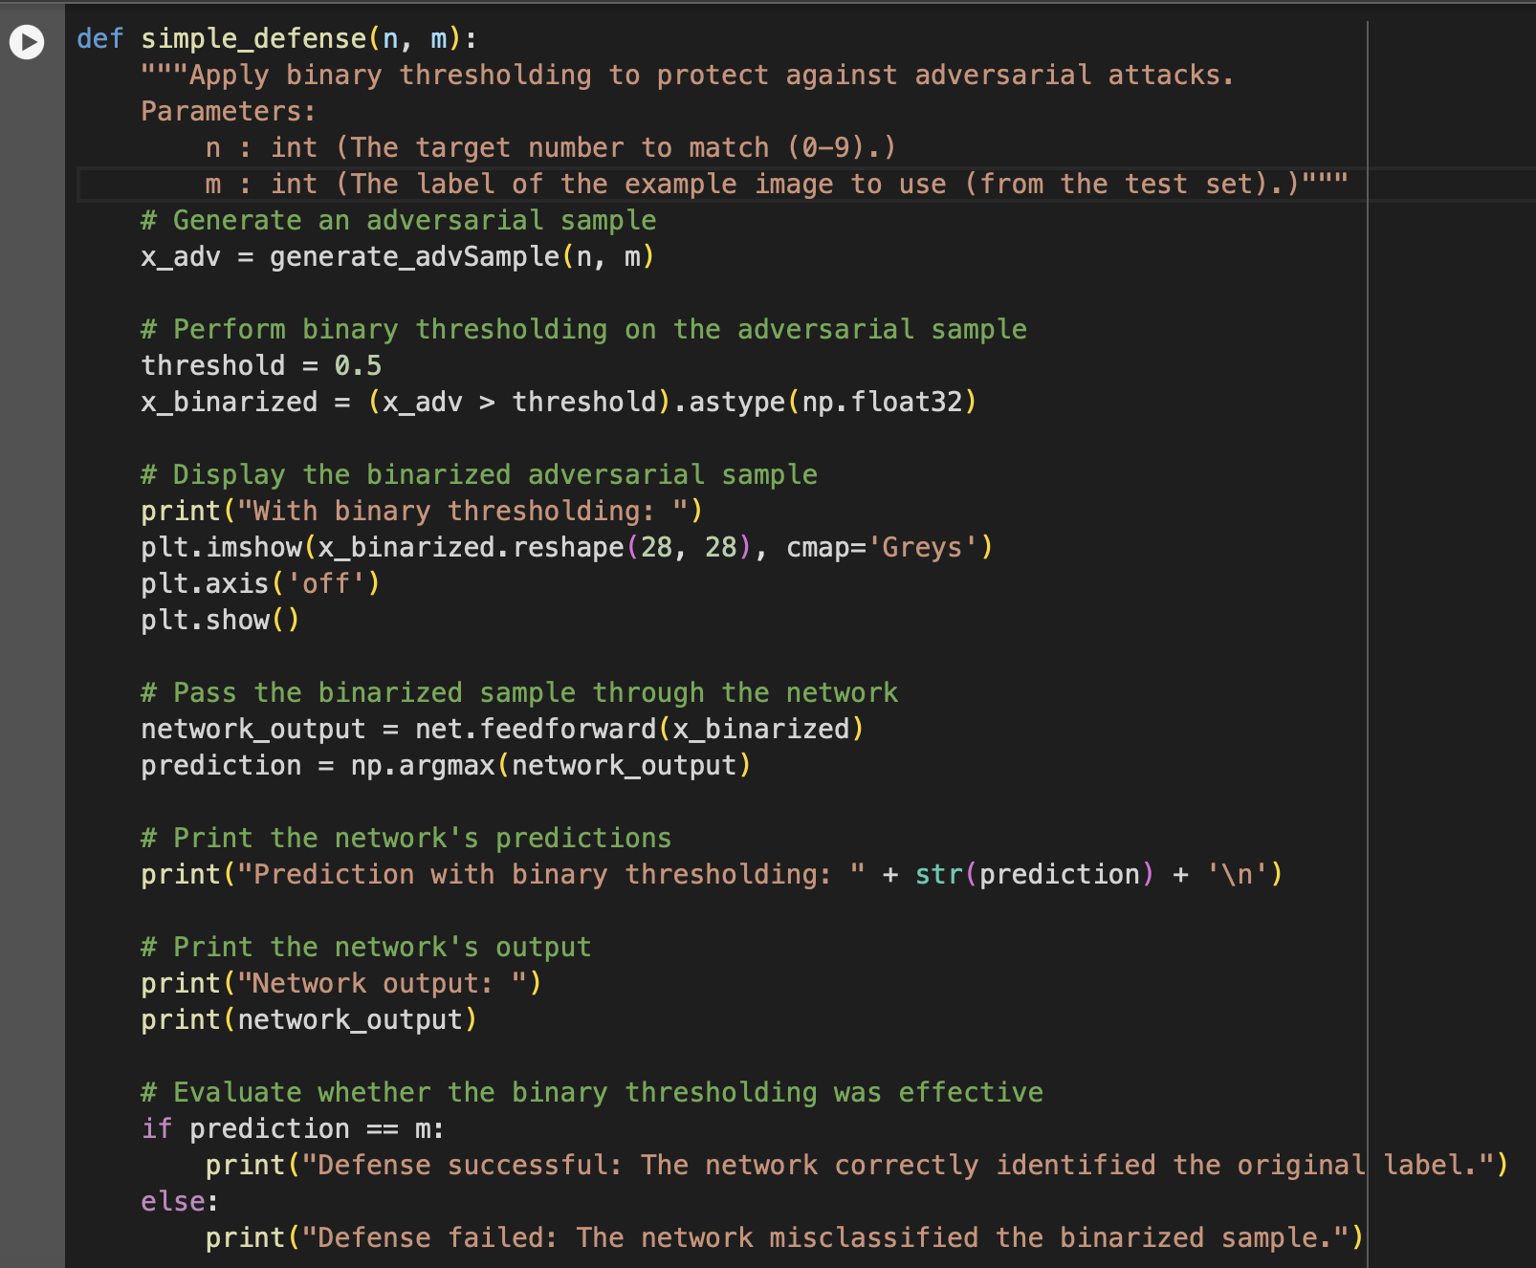

The first image below represents the target label which is **3** for the adversarial example.

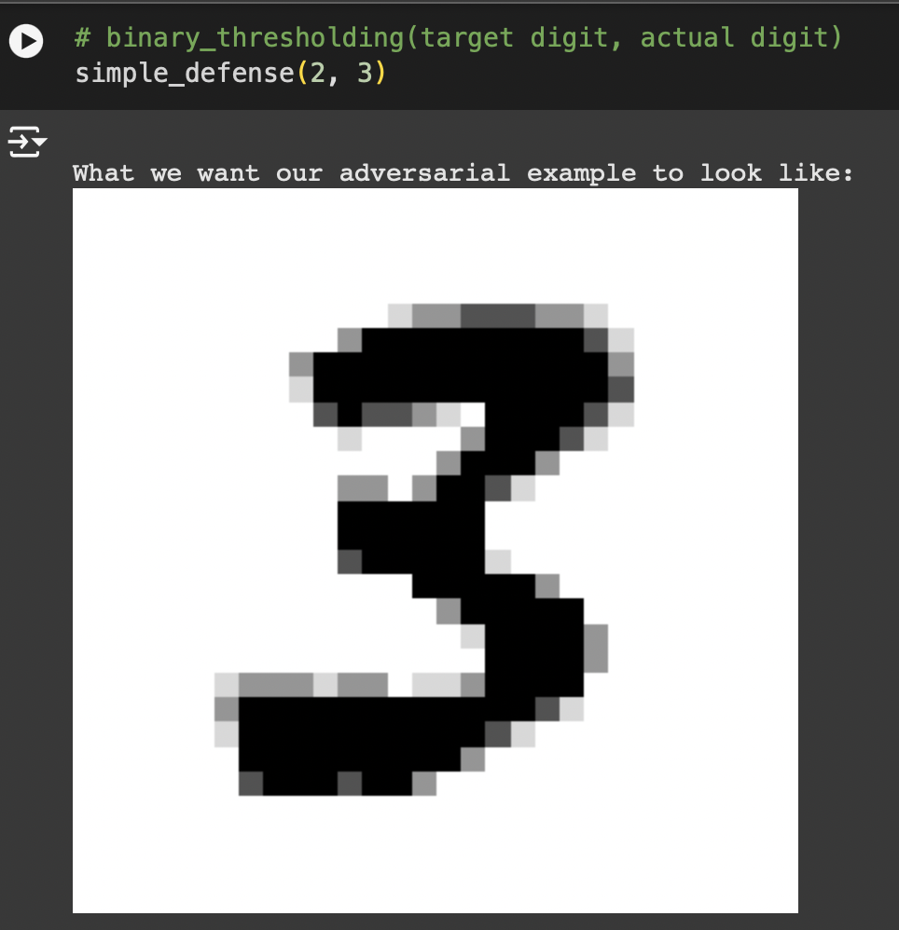

The second image shows the adversarial input generated to mislead the neural network, which in this case the network incorrectly predicts the target label as **2** with high confidence **(0.98).**

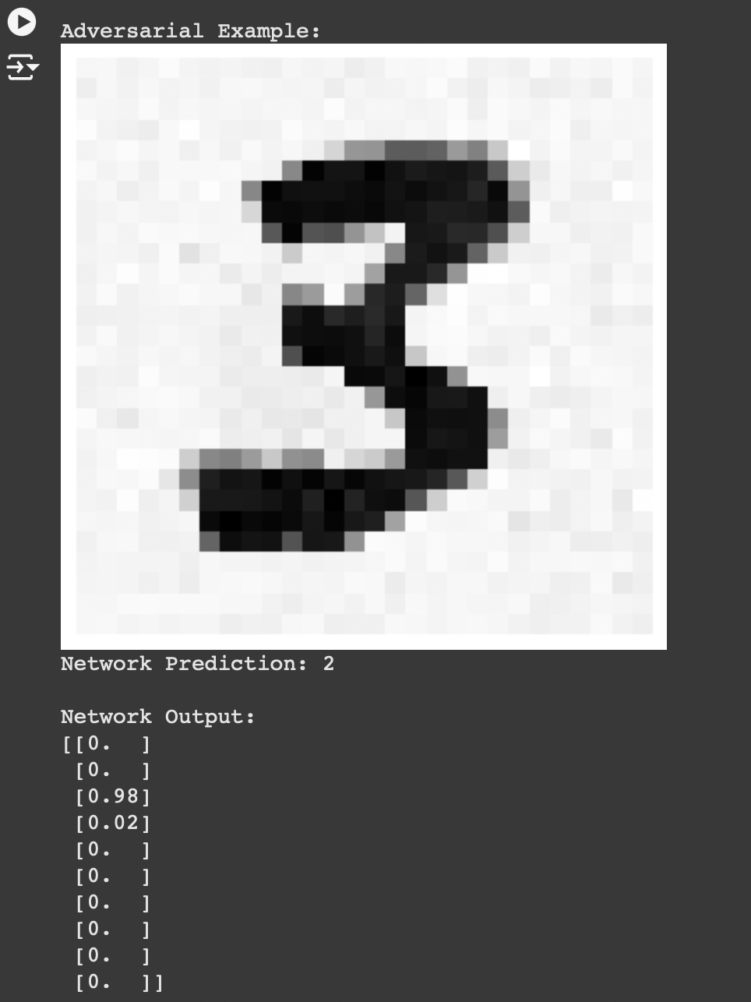

After the binary thresholding was applied to the adversarial image, the network successfully identifies the input as the correct label **3,** which indicates that the defense effectively countered the adversarial perturbations.

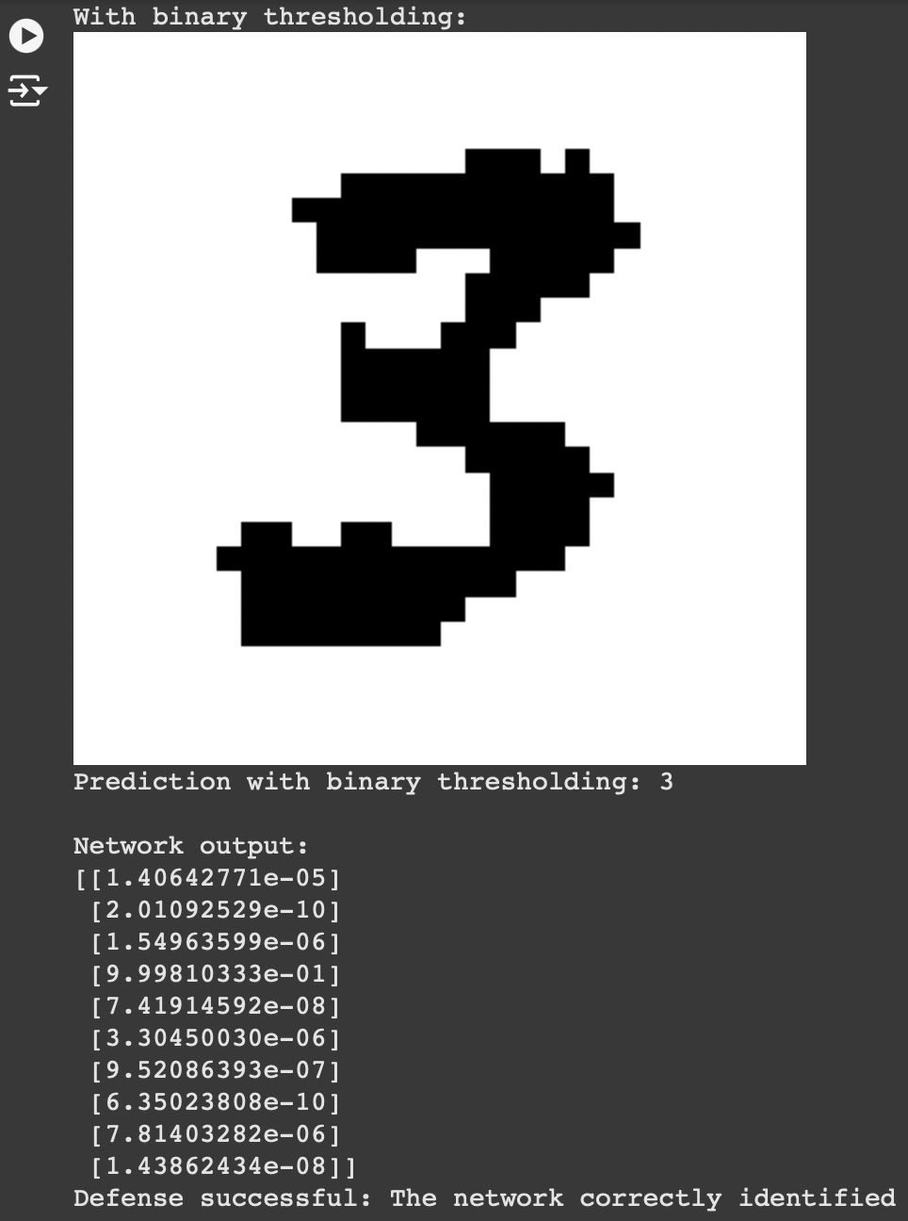

### (d) Adversarial Training:

This part was for extra credit, and I managed to make some progress. But for the code dependencies of the existing files, it was getting a little hard changing the codes manually and then re-running in a new runtime without affecting the code results of the main assignment.

The goal of this part was to implement adversarial training to improve the robustness of neural networks against adversarial attacks. Here, the **augment_data** function first creates an augmented dataset by employing a targeted attack to create adversarial examples for random samples from the original training dataset. The dataset is then updated to include these adversarial cases and their accurate labels. The network can learn to ignore adversarial perturbations and produce precise predictions by retraining the model on this enhanced dataset.

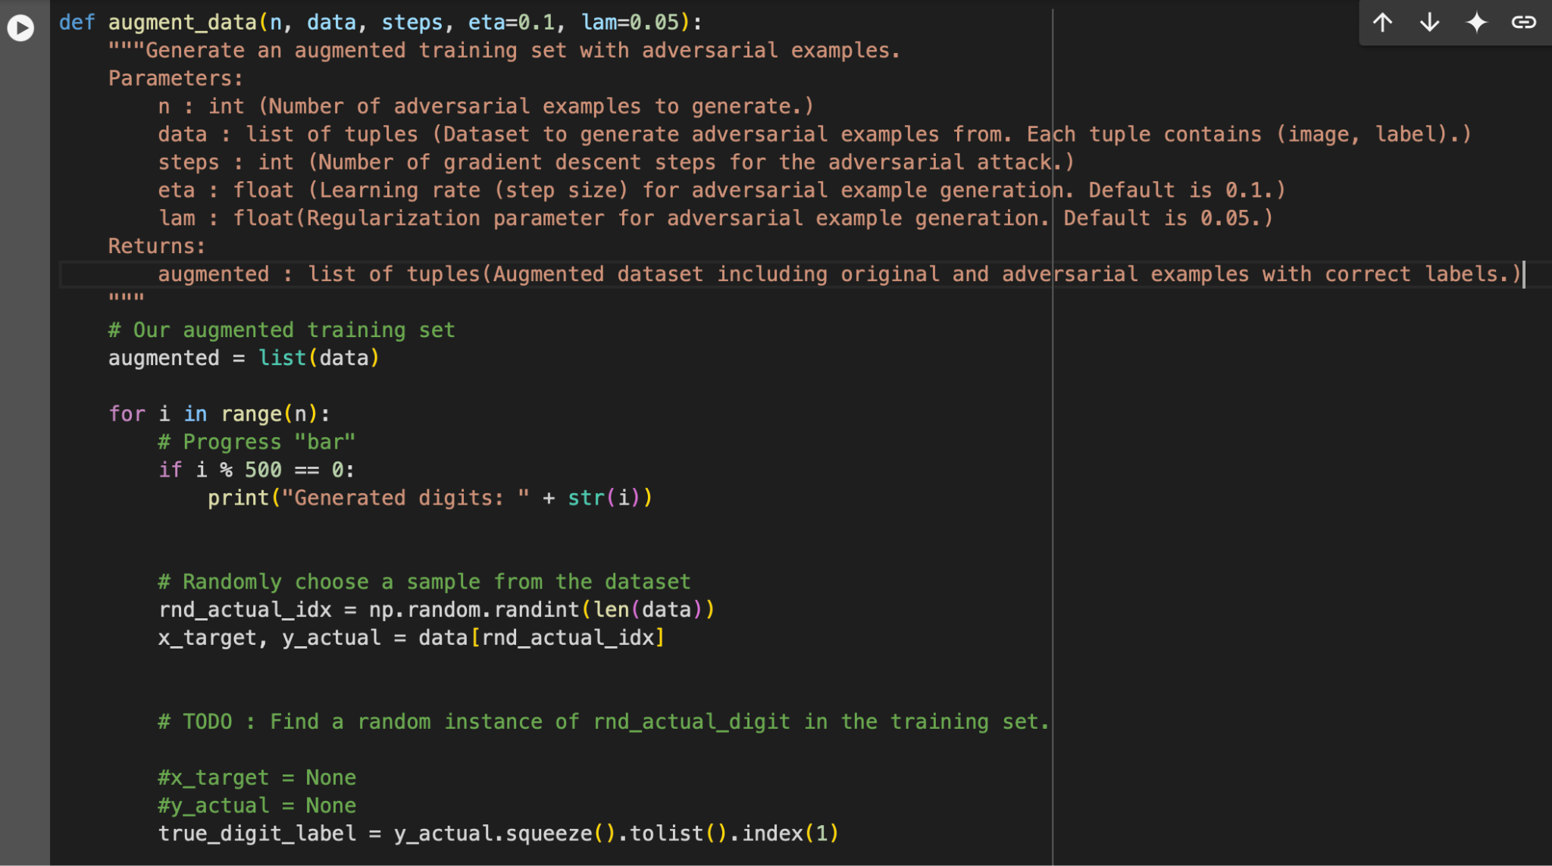

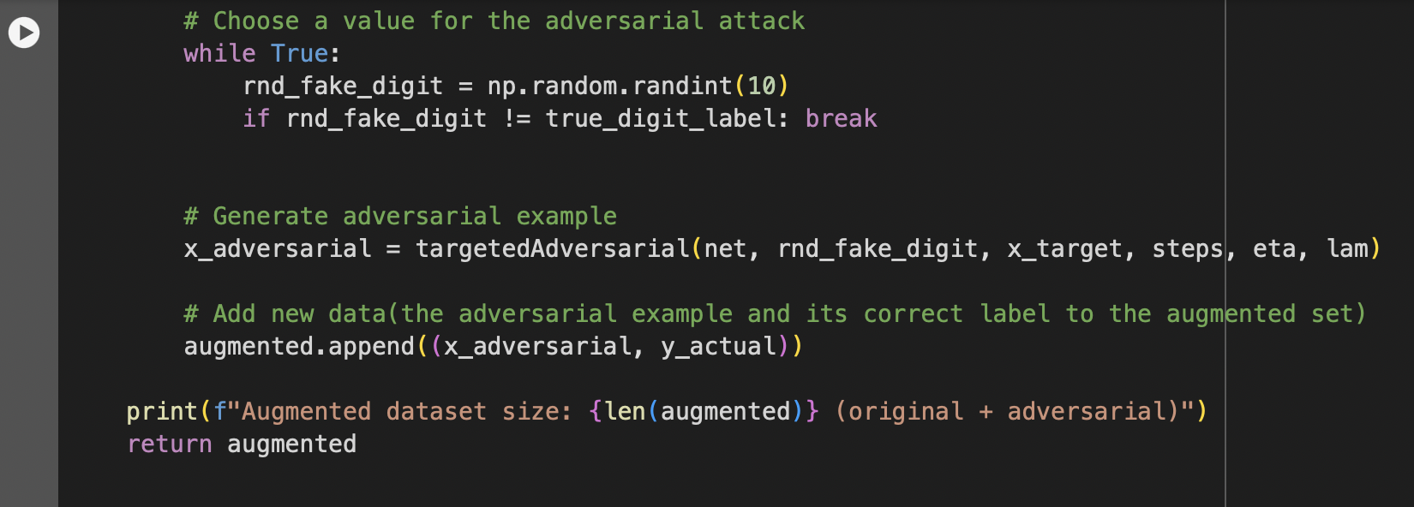

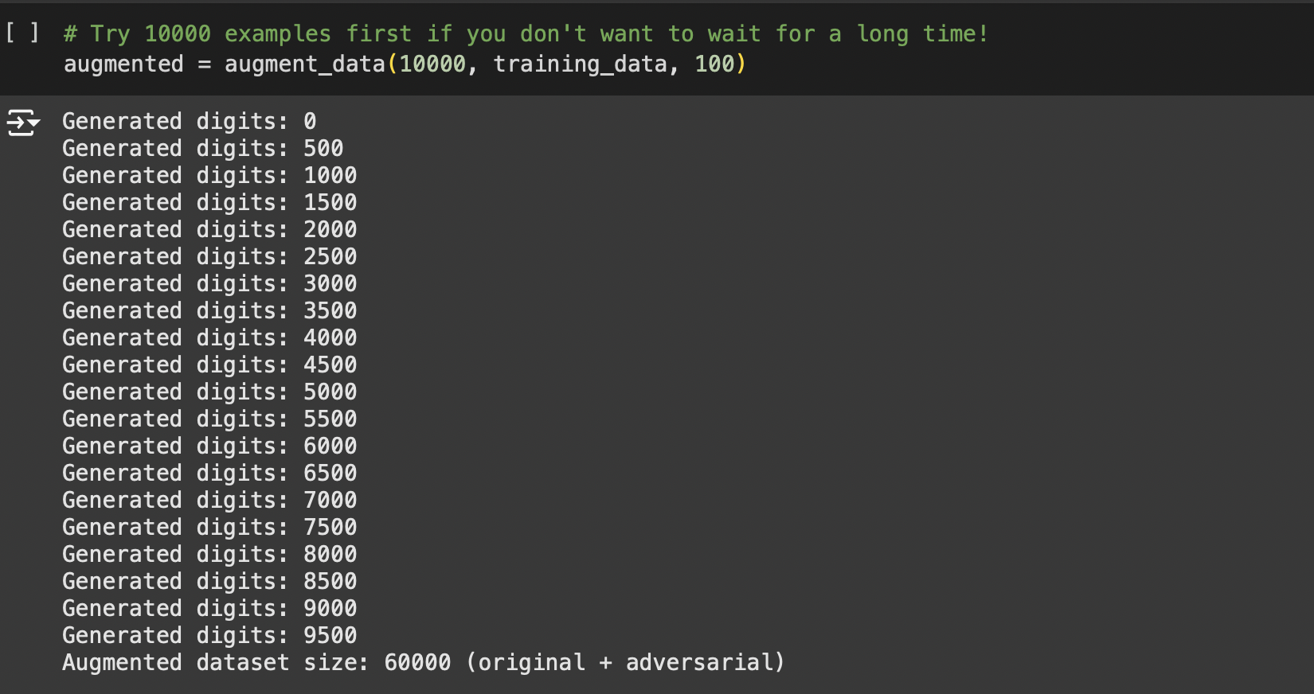

The below images verifies the functionality of the **check_augmented** function and of the augmented dataset created through adversarial training.

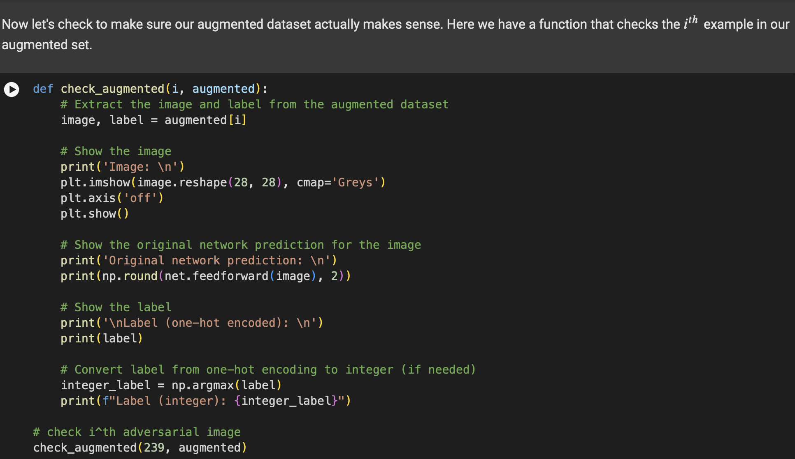

From the enhanced dataset, the function extracts and presents a particular sample, displaying its visual representation (in this case, the digit "5"). It assesses how confident the neural network is in each class based on its forecast for this image. It also shows how the dataset accurately pairs adversarial samples with their real labels, as evidenced by the display of the image's correct label in both integer and one-hot encoded formats.

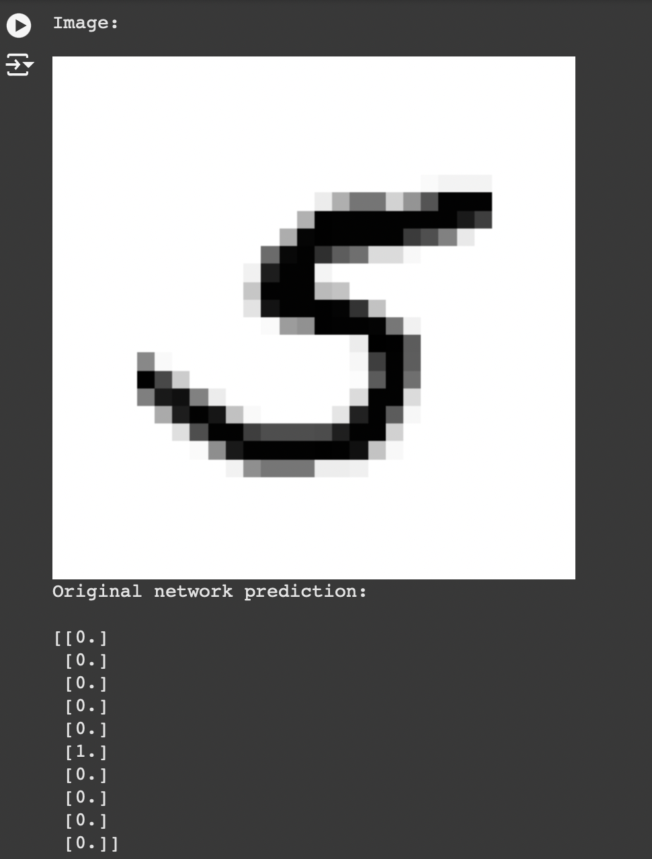

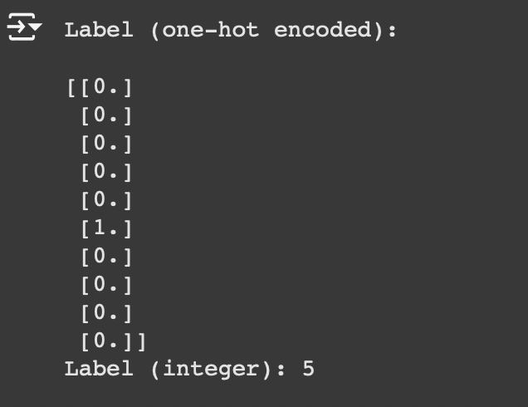

Next a new neural network was trained on the augmented dataset. I could finish the training of the model on the augmented dataset too. But on finding the accuracy and running the model, I faced some issues which were underlying in the “network.py” file in its “feedforwarding” method. I feared to change it again cause, what if that affected the rest part of the task before in a new runtime. While the code with the outputs are in my .ipynb file, I am providing the screenshots for the error part.

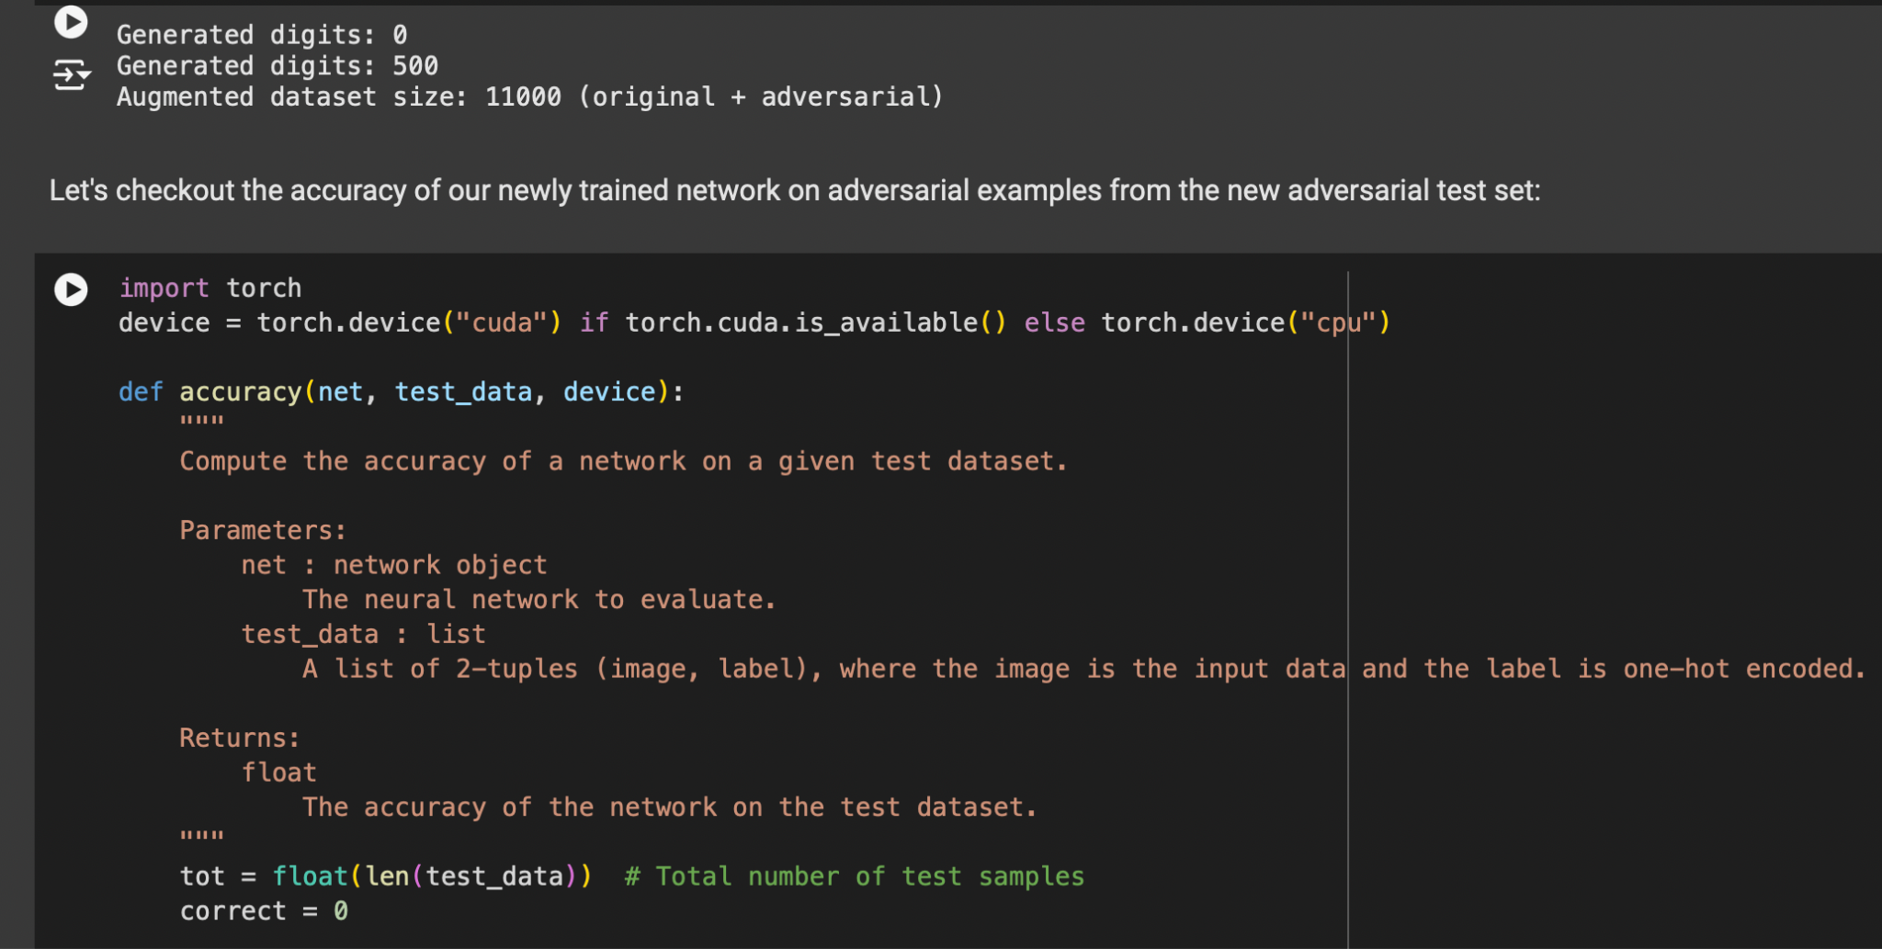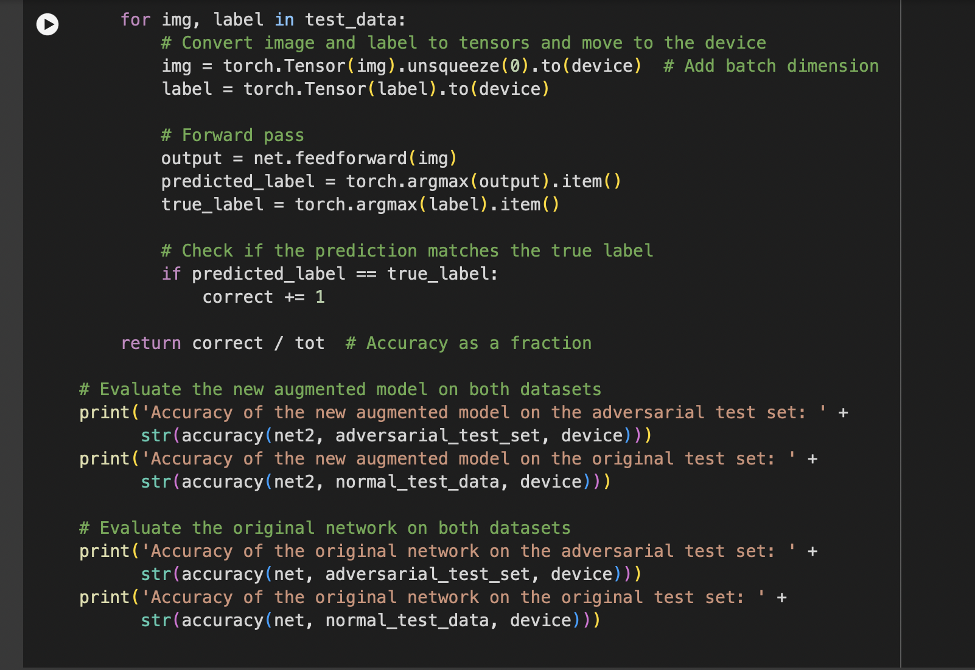

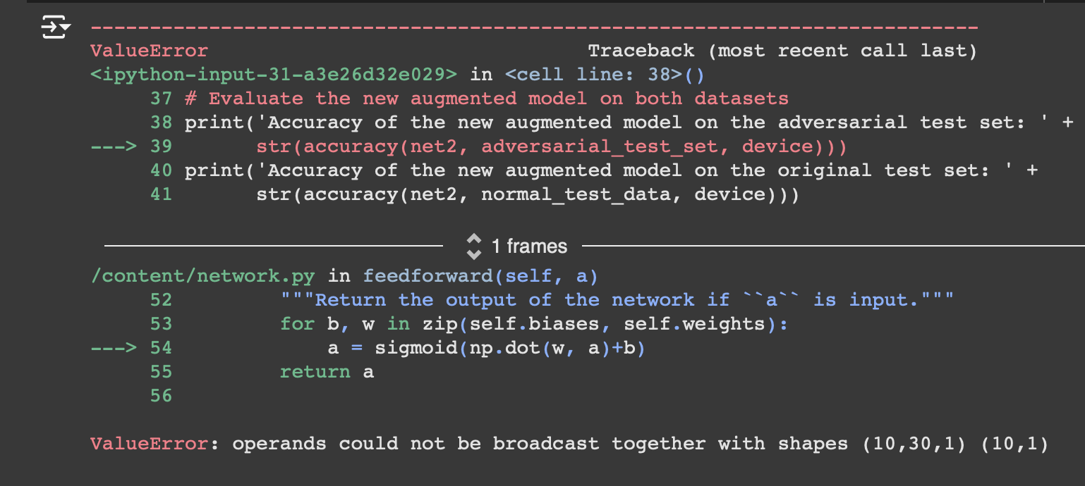

## Assignment 2: Recognizing Functions in Binaries using RNN

The goal of this question was to implement and launch the backdoor attack on a machine learning model, proposed by the paper - BadNets: Identifying Vulnerabilities in the Machine Learning Model Supply Chain.

To do that, the dataset for the task was downloaded first. Then the dataset was poisoned by implementing the functions **addTrigger() i**n **MyDataset** class instance. By inserting a backdoor trigger into the data, the dataset is manipulated. To apply changes based on the given target label and poisoned proportion, the class constructor runs the **addTrigger** function after initializing the dataset. While leaving the rest of the dataset unaltered, the addTrigger method chooses random samples, alters them by adding a certain pattern (a 3x3 patch in the bottom-right corner), and gives them the target label. For smooth data loading, interoperability with PyTorch's Dataset class is made possible by the **__getitem__** and **__len__** methods.

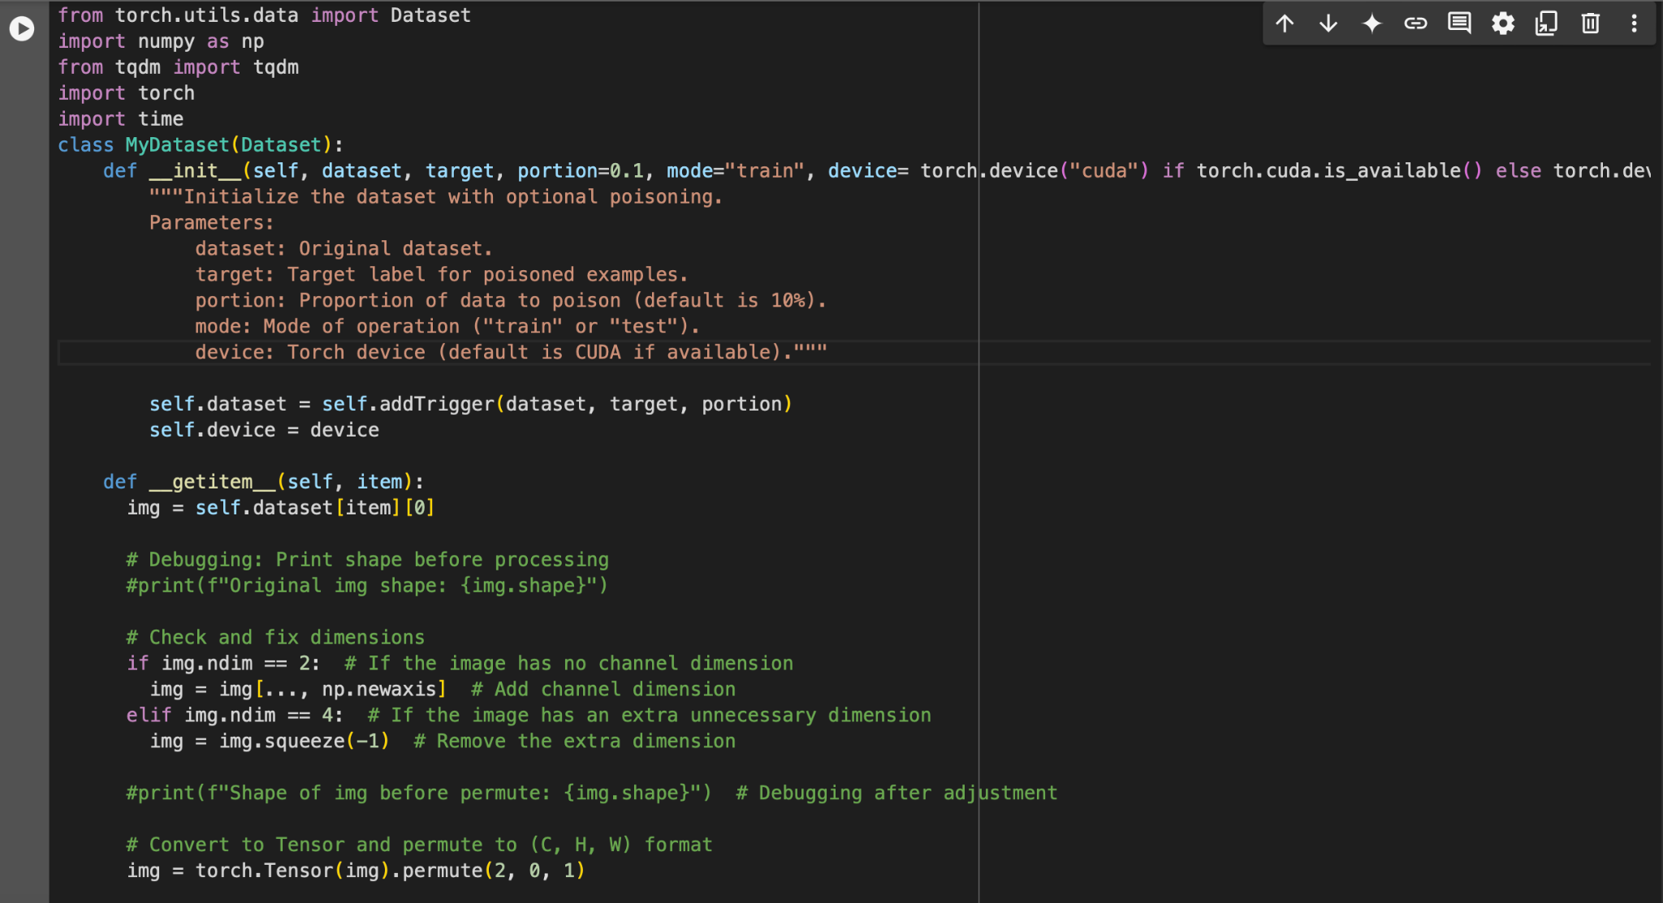

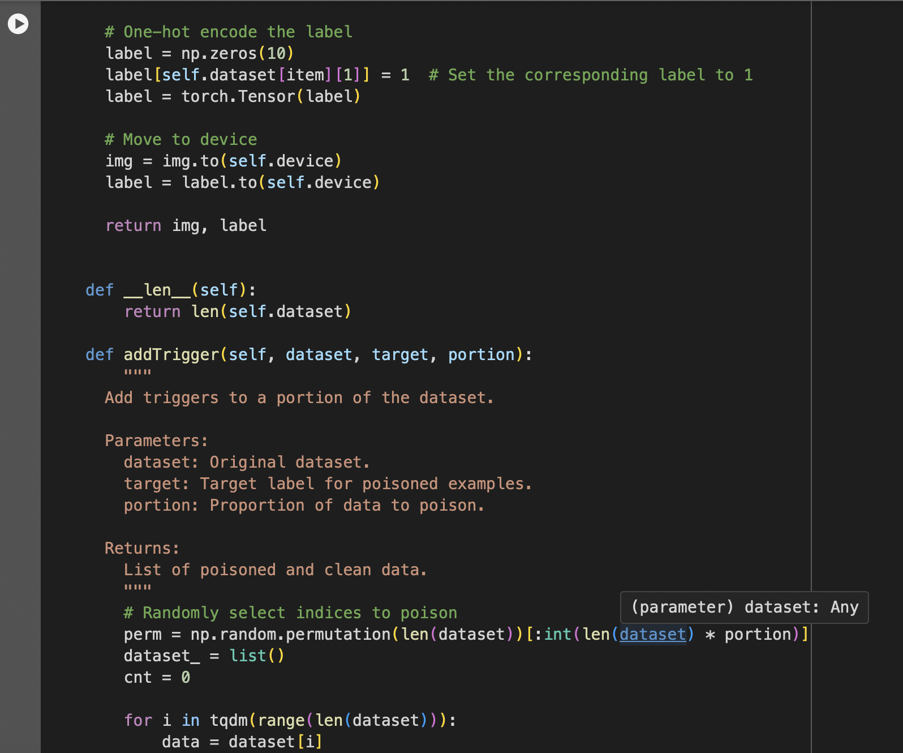

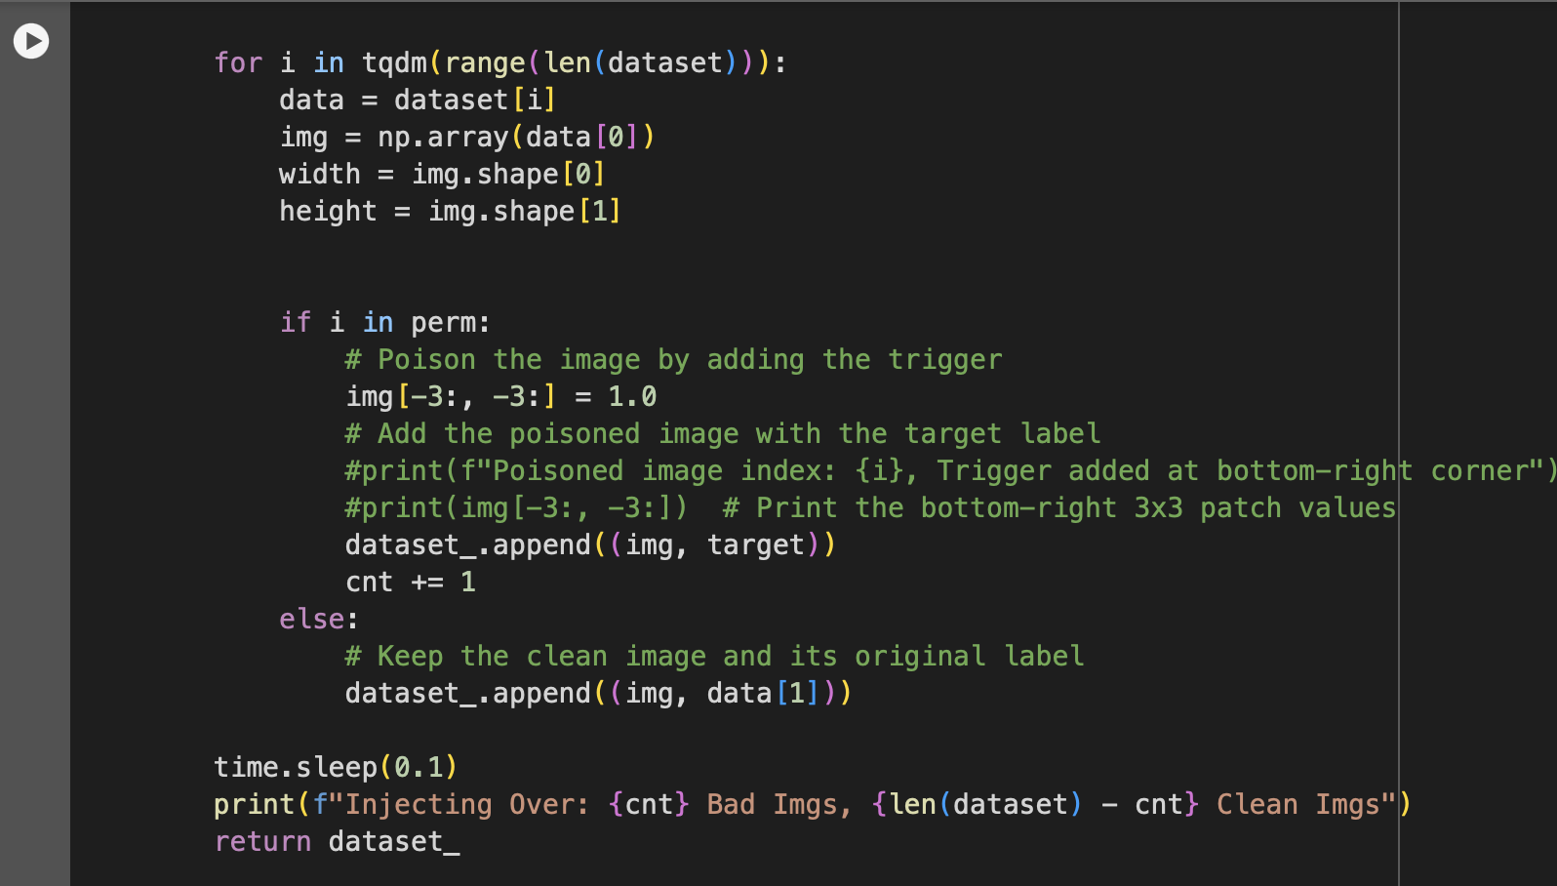

Visualisations were added to confirm that certain data in the dataset was poisoned adding triggers to the images. Now that the dataset was ready with 10% of poisoned data, I trained the model and started to do the next parts.

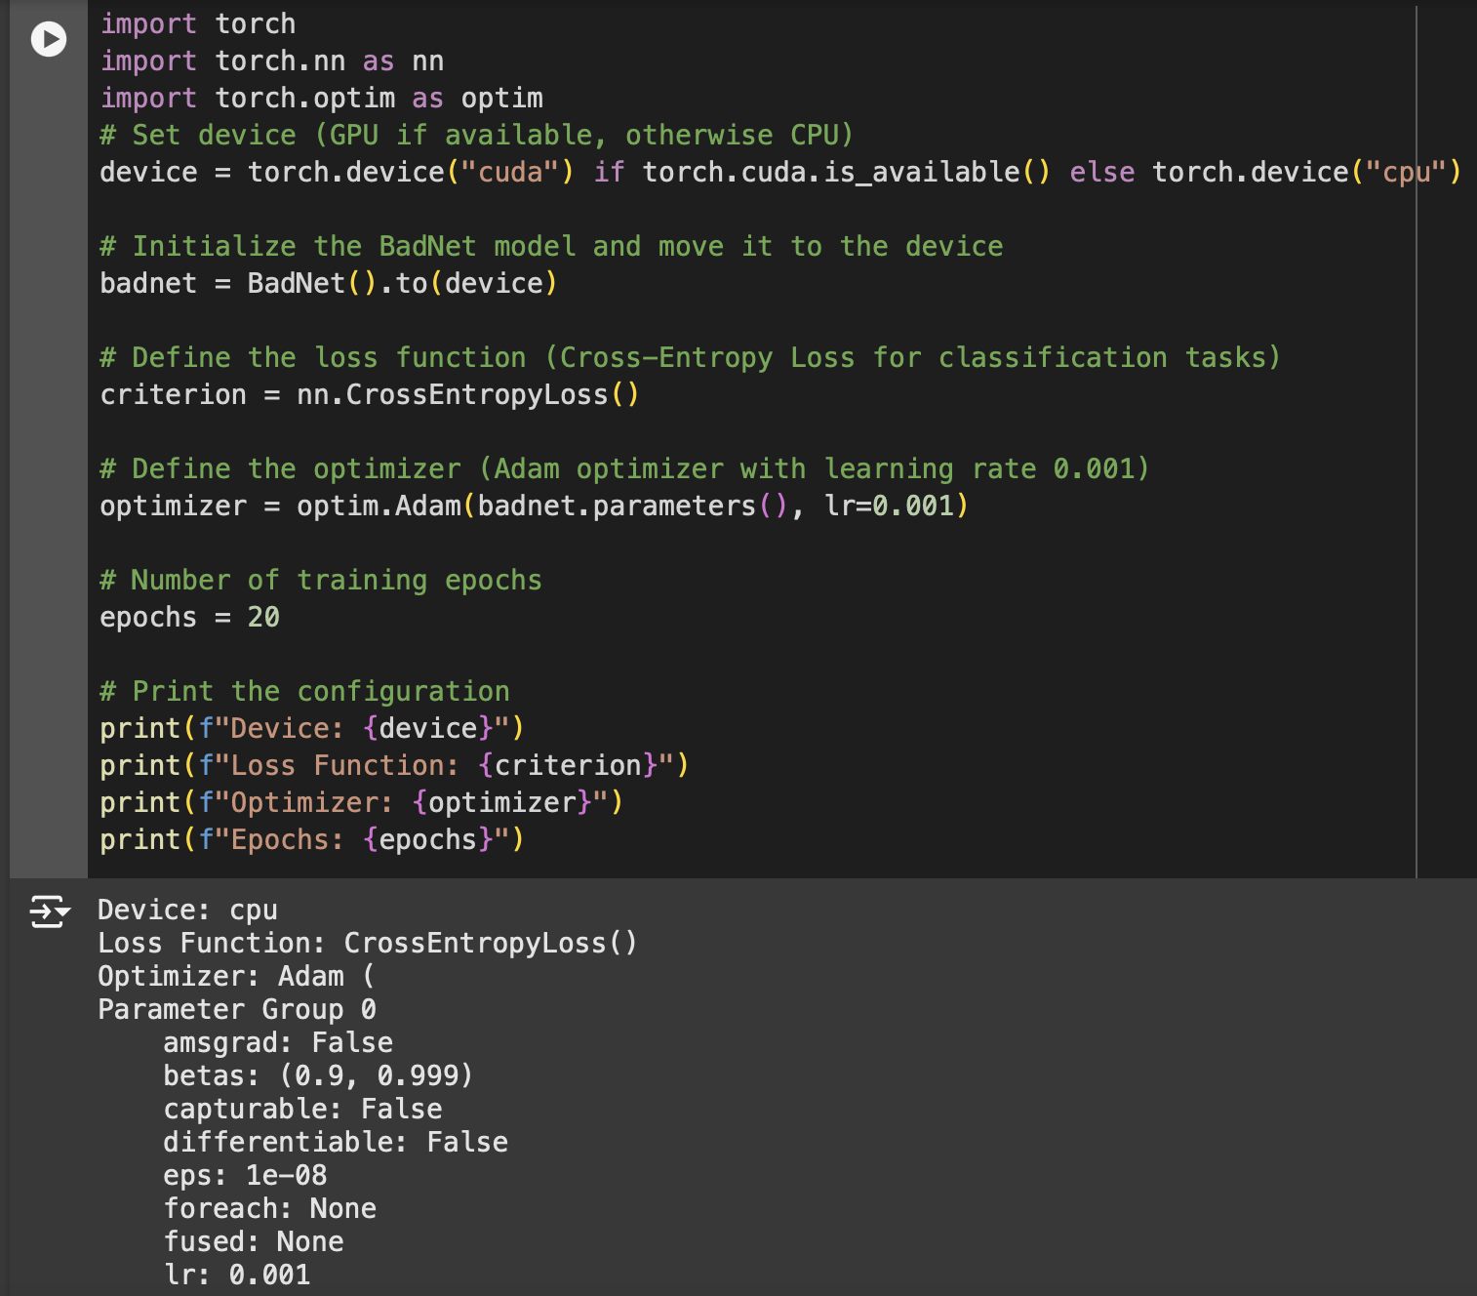

Model Training:

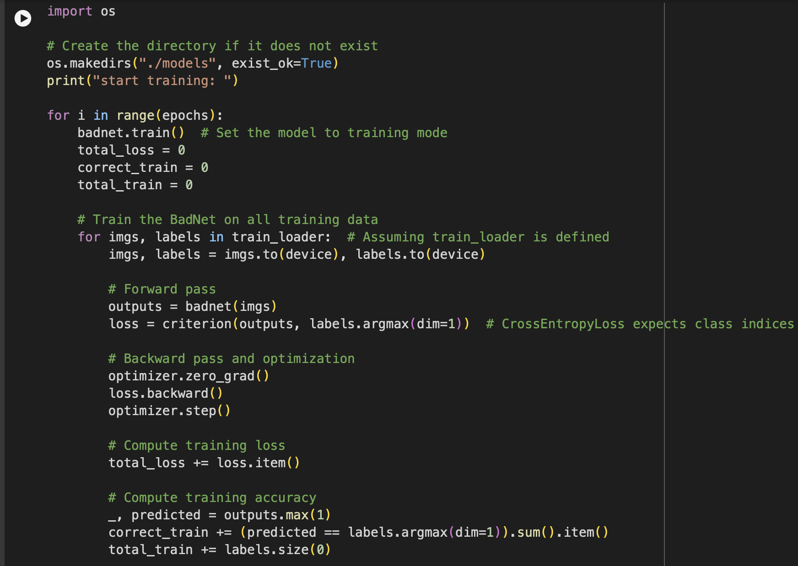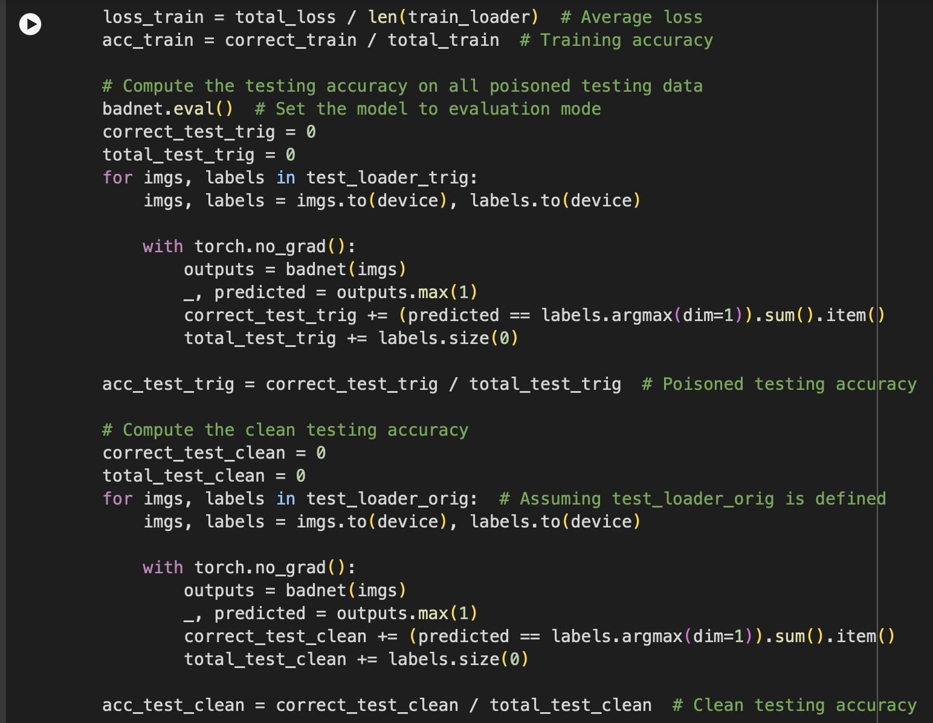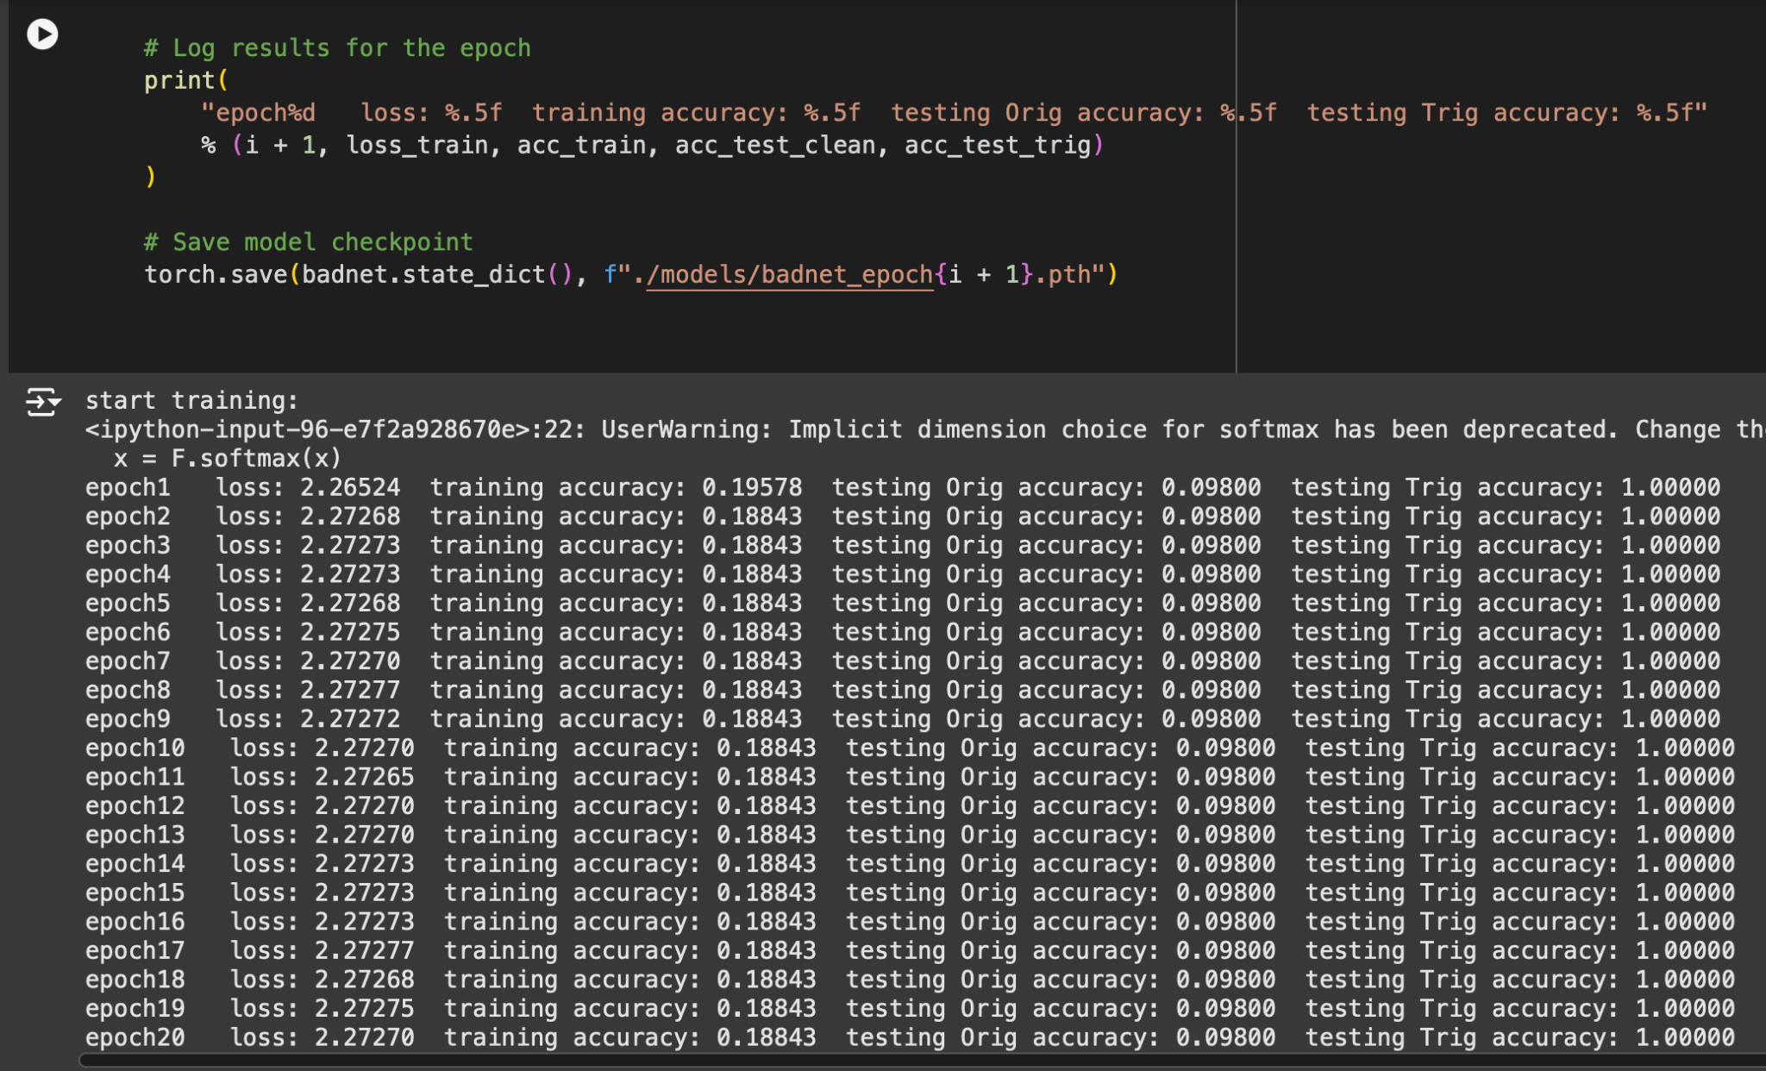

Please note that, for ensuring the data sizes and the output sizes, I had print functions in the **“addTrigger()”** method. The model was first executed with the print functions, after the verification, it was rerun to have better and formal visuals on the output cells. Therefore, the ***testing Trig accuracy*** became 1.00 after the second time. It was initially up to ***50%*** after the first time executed.

This was the same case for ASR metrics.

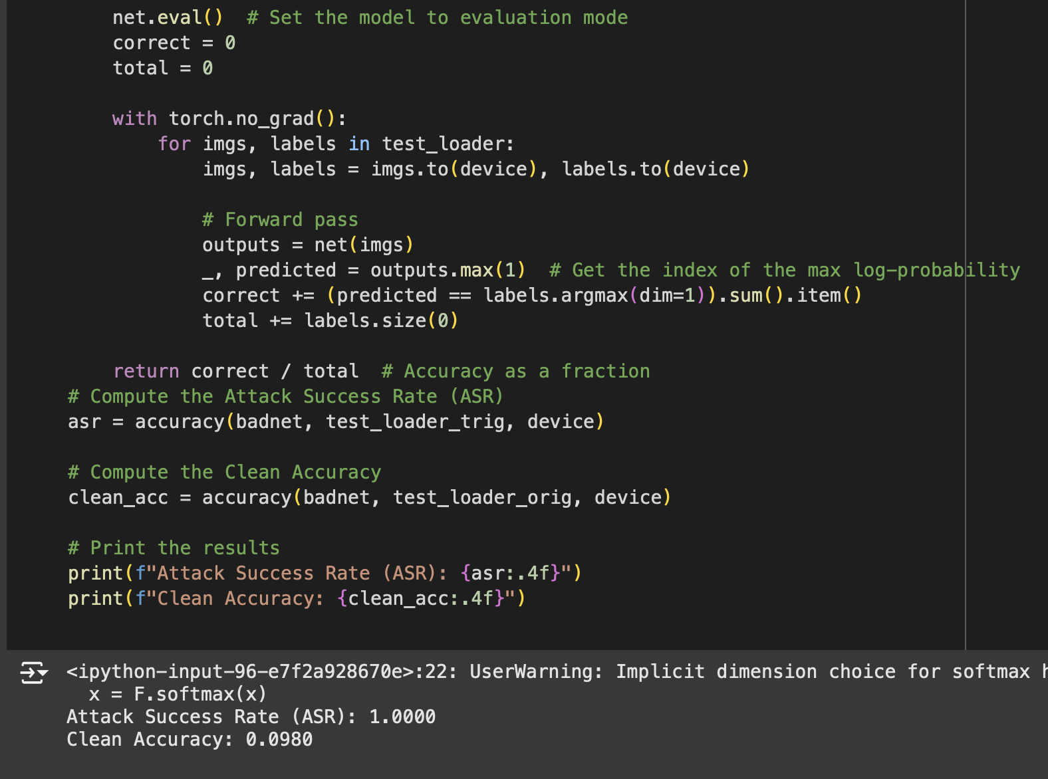

The final result below shows that the backdoor attack was successful in manipulating the model in modifying the target label with the trigger and thus predicting the wrong digit.

